**Project No: 1**

##### Project Title: Blood Donation Project Description:

Blood Donation site contains information about the number of blood banks and applicants willing to Donate blood.

It should covers the following modules:

##### Register, Why to donate blood, who can give blood, Refer a friend, Contact us

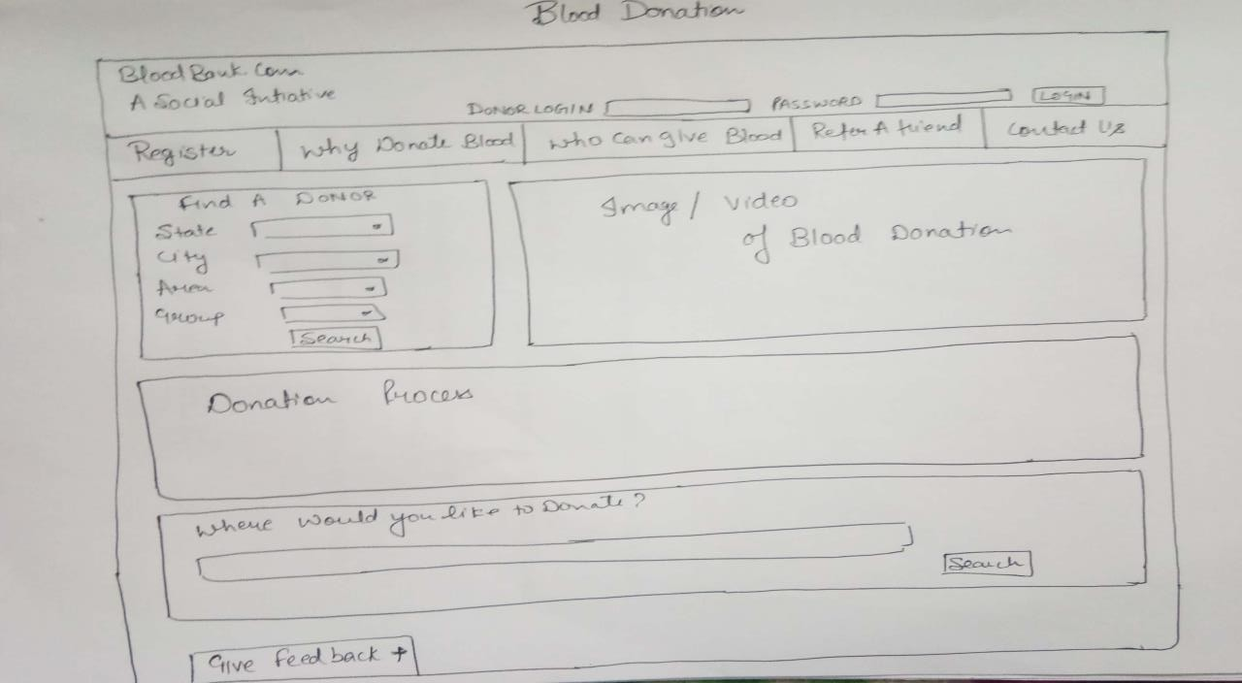

**Rubrics:**

* Pre-submission report - includes module wise description, role and responsibility of each group members and work plan as Gantt chart (5 Marks)
* Final report (5 Marks)
* Viva and Implementation ( 10+10 Marks)

**Project No: 2**

##### Project Title: Restaurant

**Project Description:** It should covers the following modules:

##### Home, About us, Menu, Gallery, Healthy tips, Contact us

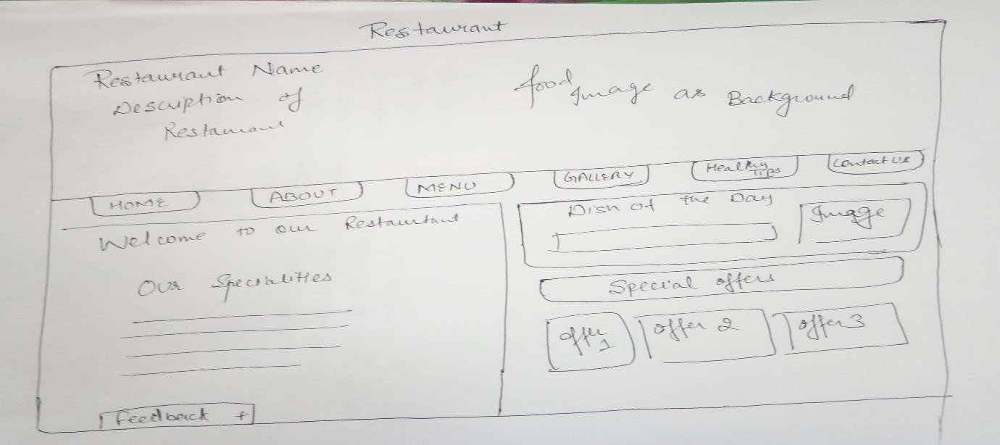

**Rubrics:**

* Pre-submission report - includes module wise description, role and responsibility of each group members and work plan as Gantt chart (5 Marks)
* Final report (5 Marks)
* Viva and Implementation ( 10+10 Marks)

**Project No: 3**

### Project Title: Property Website

**Project Description:** It should covers the following modules:

##### Buy, Rent, Sell, Contact us, Sign up

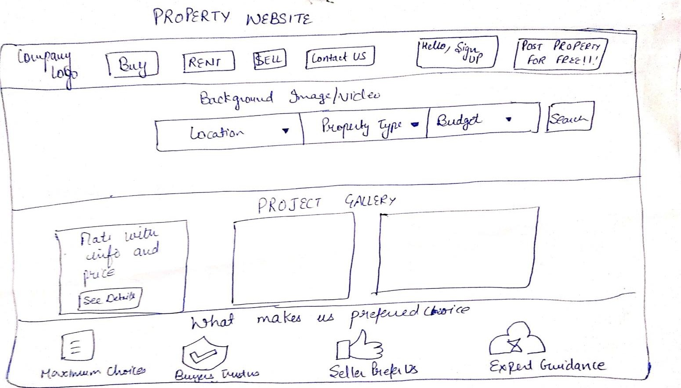

**Rubrics:**

* Pre-submission report - includes module wise description, role and responsibility of each group members and work plan as Gantt chart (5 Marks)
* Final report (5 Marks)
* Viva and Implementation ( 10+10 Marks)

**Project No: 4**

### Project Title: Car Rental System

**Project Description:** It should include the following modules

##### Sign up, login, manage booking, popular locations

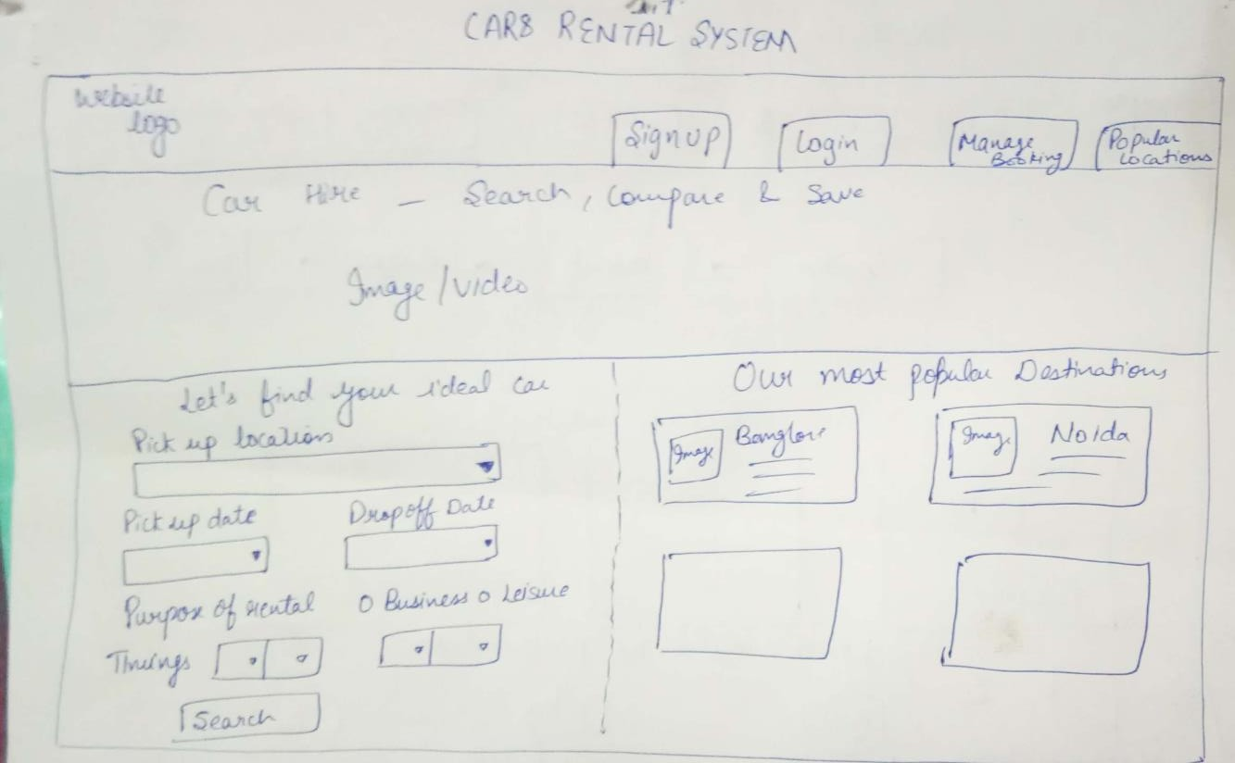

**Rubrics:**

* Pre-submission report - includes module wise description, role and responsibility of each group members and work plan as Gantt chart (5 Marks)
* Final report (5 Marks)
* Viva and Implementation ( 10+10 Marks)

**Project No: 5**

### Project Title: Grocery website

**Project Description:** It should include the following modules

##### Revolution, products, advantages, contact us

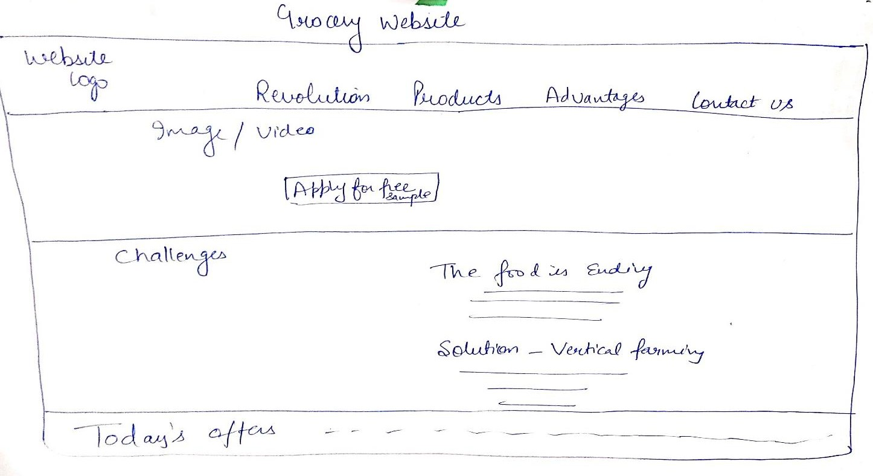

**Rubrics:**

* Pre-submission report - includes module wise description, role and responsibility of each group members and work plan as Gantt chart (5 Marks)
* Final report (5 Marks)
* Viva and Implementation ( 10+10 Marks)

**Project No: 6**

### Project Title: Fitness Club

**Project Description:** It should include the following modules

##### About us, trainings, timetable, nutrition, gallery

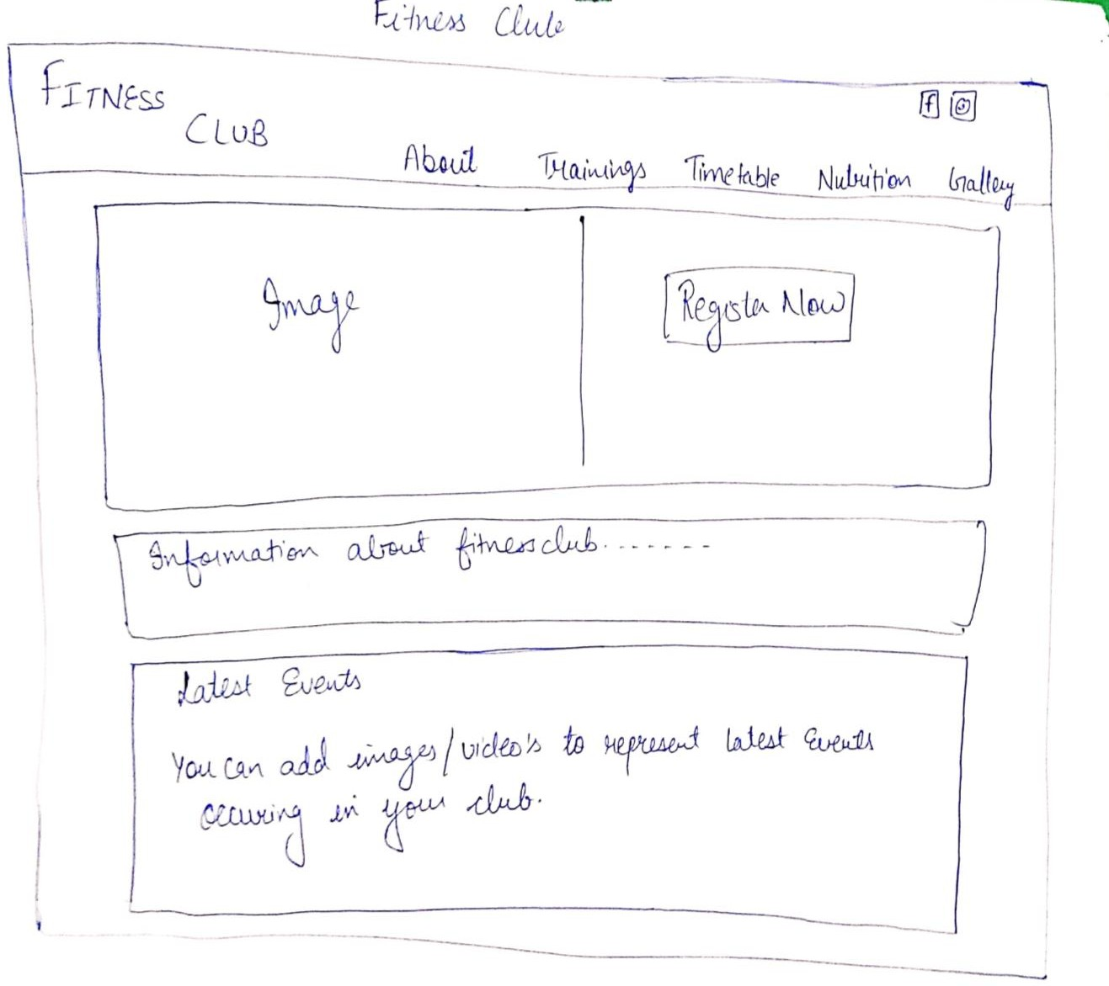

**Rubrics:**

* Pre-submission report - includes module wise description, role and responsibility of each group members and work plan as Gantt chart (5 Marks)
* Final report (5 Marks)
* Viva and Implementation ( 10+10 Marks)

**Project No: 7**

### Project Title: Railway Reservation System

**Project Description:** It should include the following modules

##### Home, Meals, Holiday Packages, Service at station, Contact us

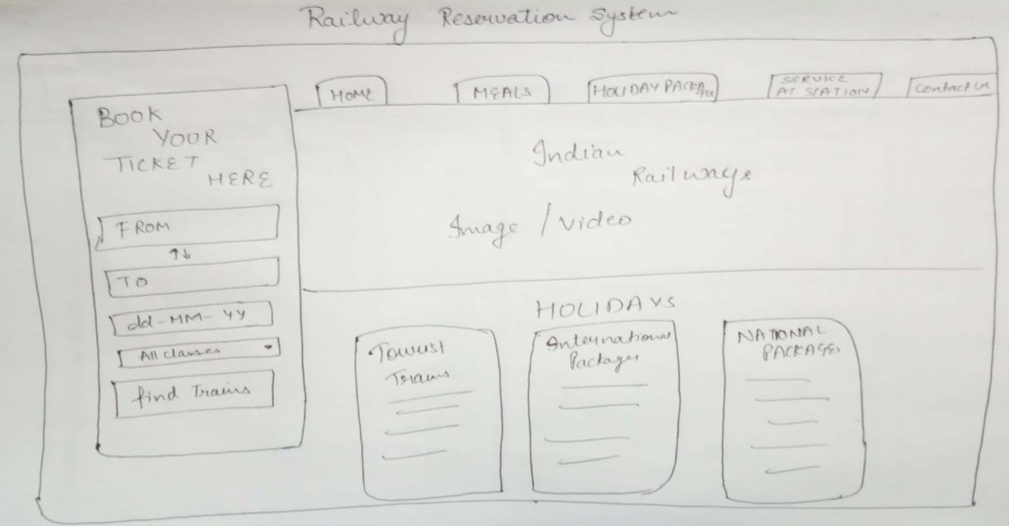

**Rubrics:**

* Pre-submission report - includes module wise description, role and responsibility of each group members and work plan as Gantt chart (5 Marks)
* Final report (5 Marks)
* Viva and Implementation ( 10+10 Marks)

**Project No: 8**

### Project Title: Learning System

**Project Description:** It should include the following modules

##### Videos, Tutors, test yourself, contact us, topics

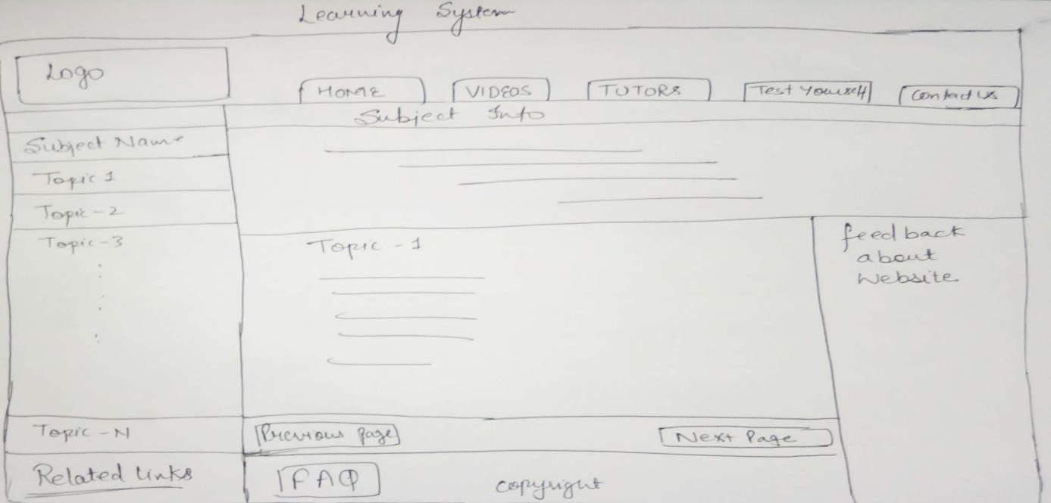

**Rubrics:**

* Pre-submission report - includes module wise description, role and responsibility of each group members and work plan as Gantt chart (5 Marks)
* Final report (5 Marks)
* Viva and Implementation ( 10+10 Marks)

**Project No: 9**

### Project Title: University Management System

**Project Description:** It should include the following modules

##### Home, timetable, examination, change password, login

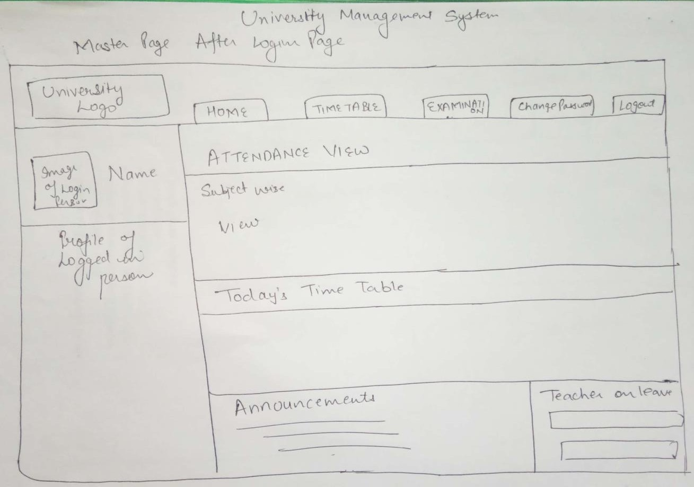

**Rubrics:**

* Pre-submission report - includes module wise description, role and responsibility of each group members and work plan as Gantt chart (5 Marks)
* Final report (5 Marks)
* Viva and Implementation ( 10+10 Marks)

**Project No: 10**

### Project Title: Construction website

**Project Description:** It should include the following modules

##### Home, About us/ history, our business, projects, media, career, contact us

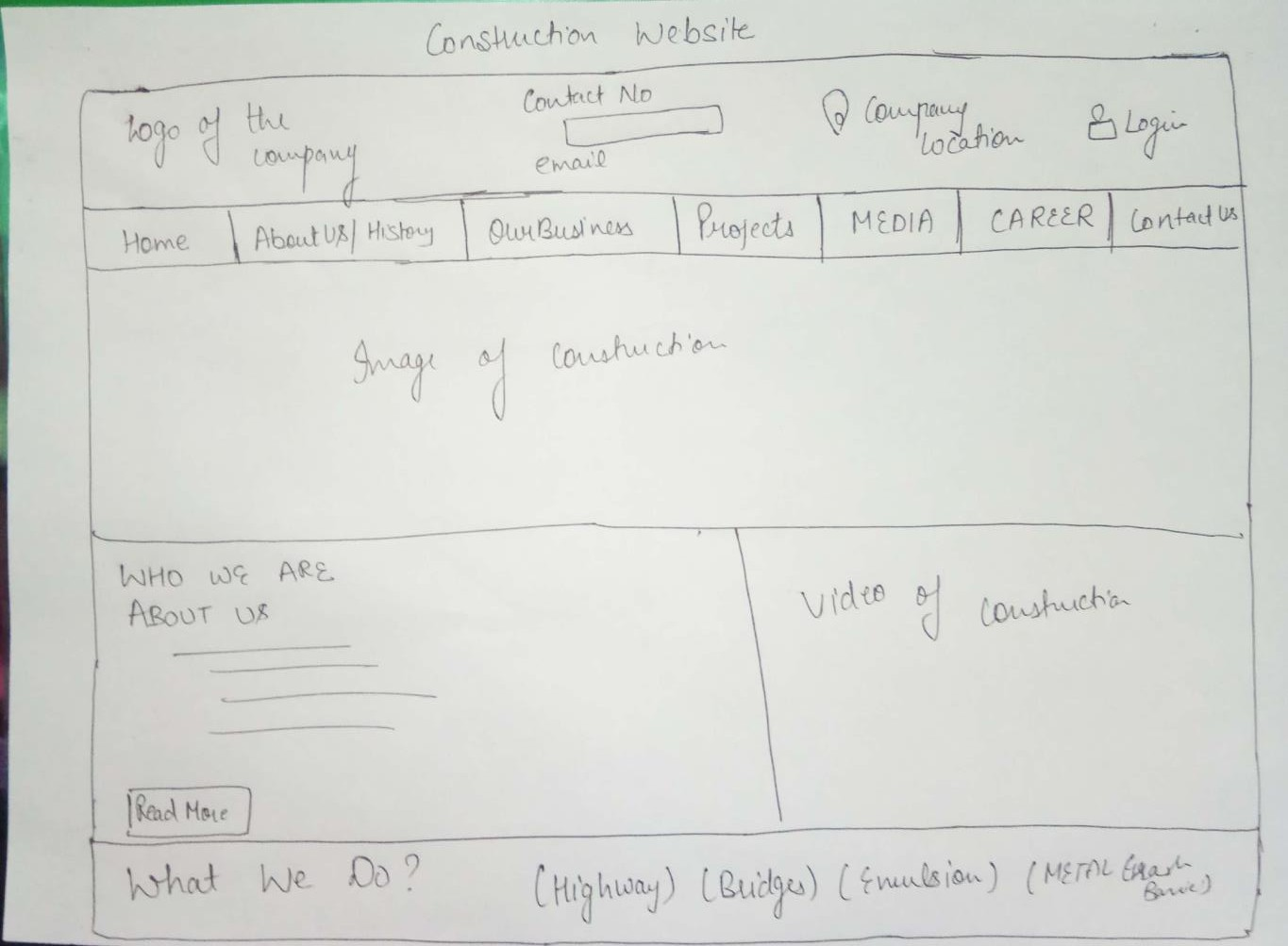

**Rubrics:**

* Pre-submission report - includes module wise description, role and responsibility of each group members and work plan as Gantt chart (5 Marks)
* Final report (5 Marks)
* Viva and Implementation ( 10+10 Marks)

**Project no.11**

**Marketing Website**

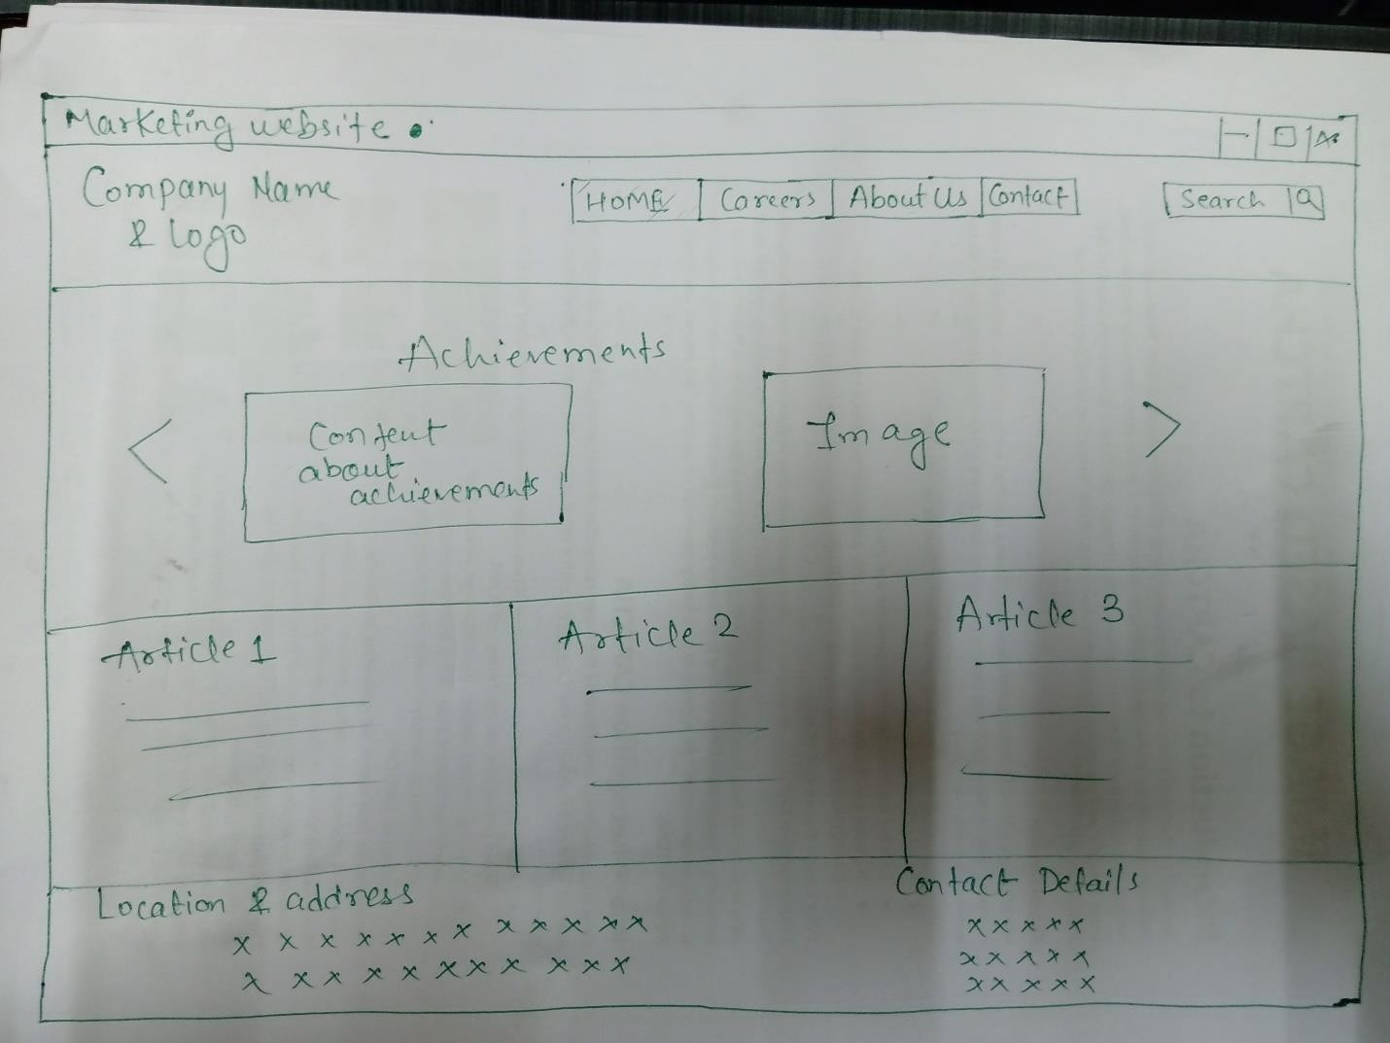

##### Rubrics:

* Pre-submission report - includes module wise description, role and responsibility of each group members and work plan as Gantt chart (5 Marks)
* Final report (5 Marks)
* Viva and Implementation ( 10+10 Marks)

**Project no. 12 Educational Website**

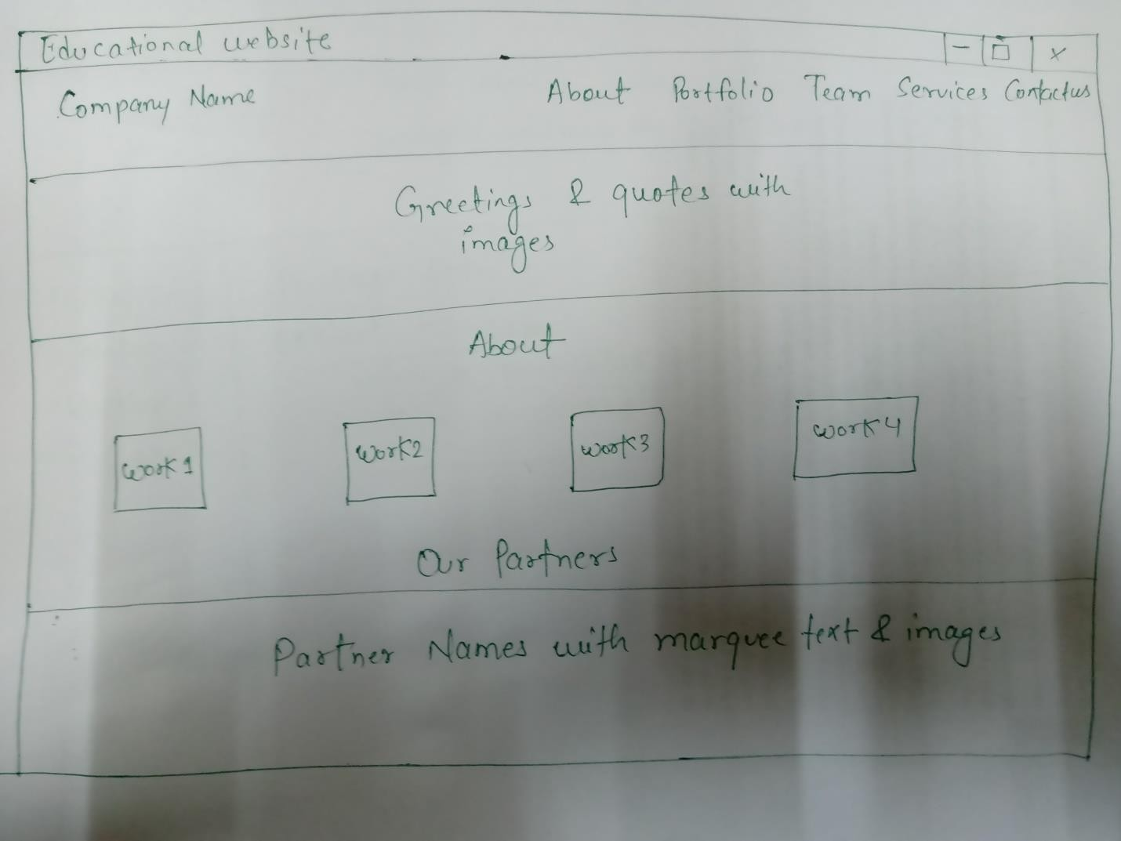

##### Rubrics:

* Pre-submission report - includes module wise description, role and responsibility of each group members and work plan as Gantt chart (5 Marks)
* Final report (5 Marks)
* Viva and Implementation ( 10+10 Marks)

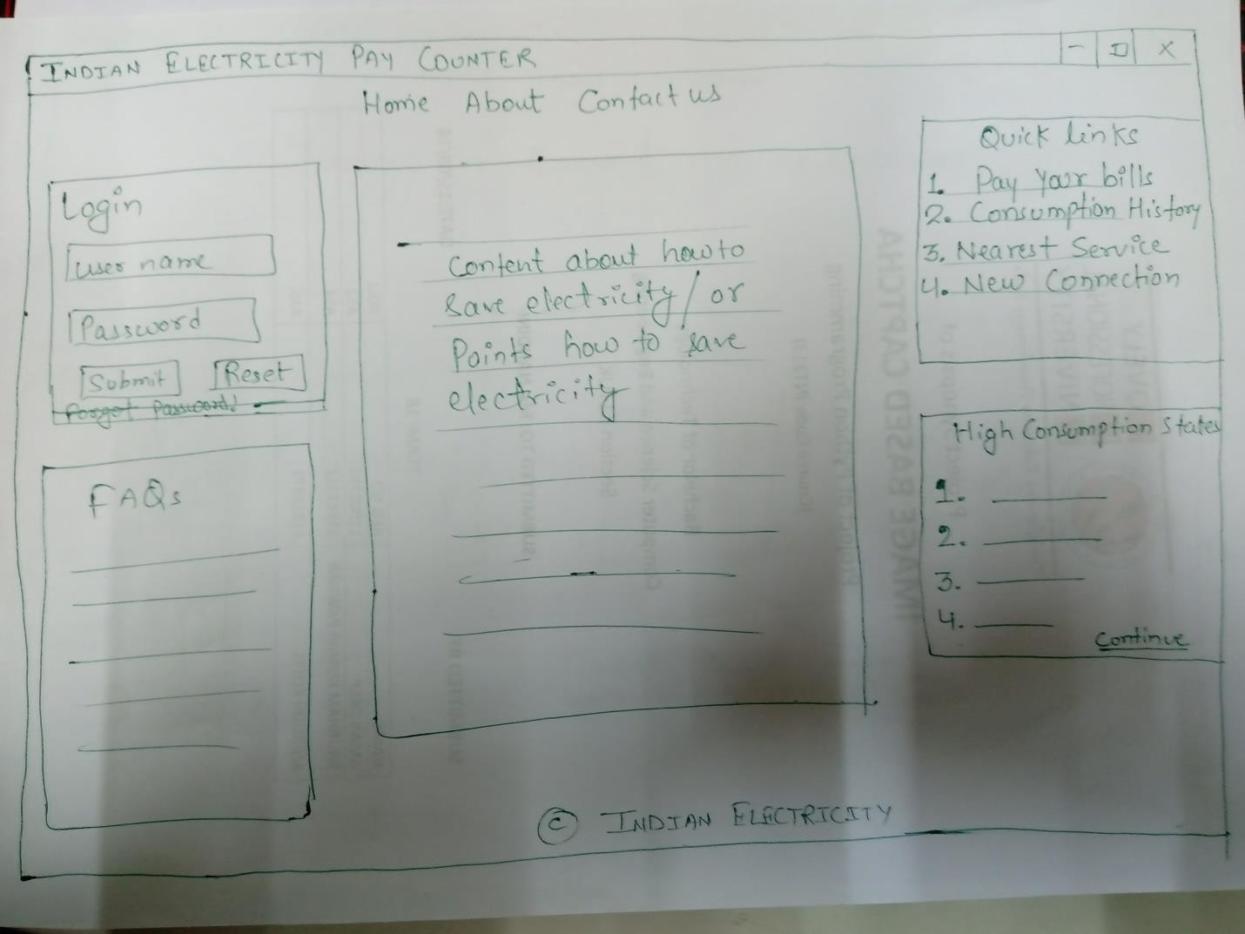

##### Rubrics:

Project 13 **Indian Electricity Website**

* Pre-submission report - includes module wise description, role and responsibility of each group members and work plan as Gantt chart (5 Marks)
* Final report (5 Marks)
* Viva and Implementation ( 10+10 Marks)

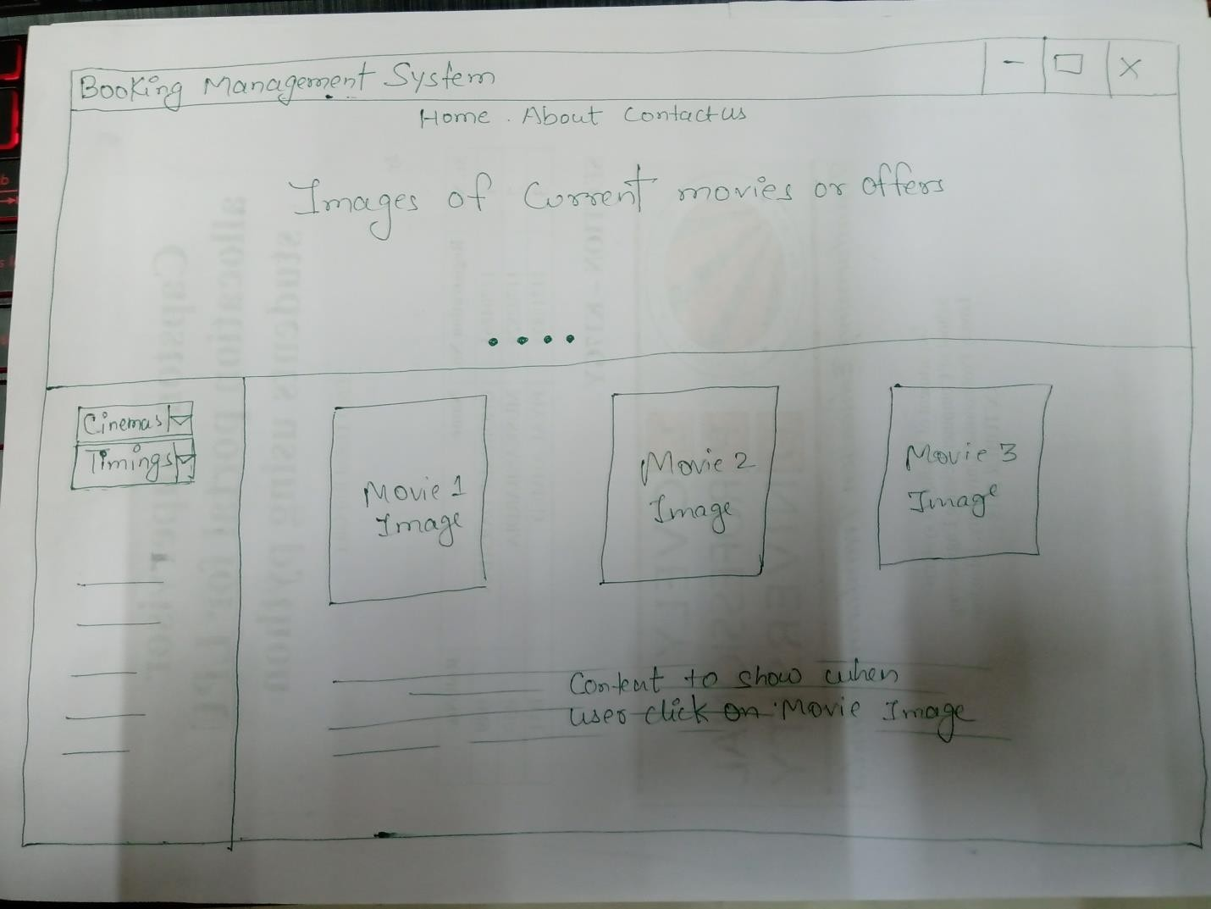

##### Rubrics:

Project 14 **Booking management System**

* Pre-submission report - includes module wise description, role and responsibility of each group members and work plan as Gantt chart (5 Marks)
* Final report (5 Marks)
* Viva and Implementation ( 10+10 Marks)

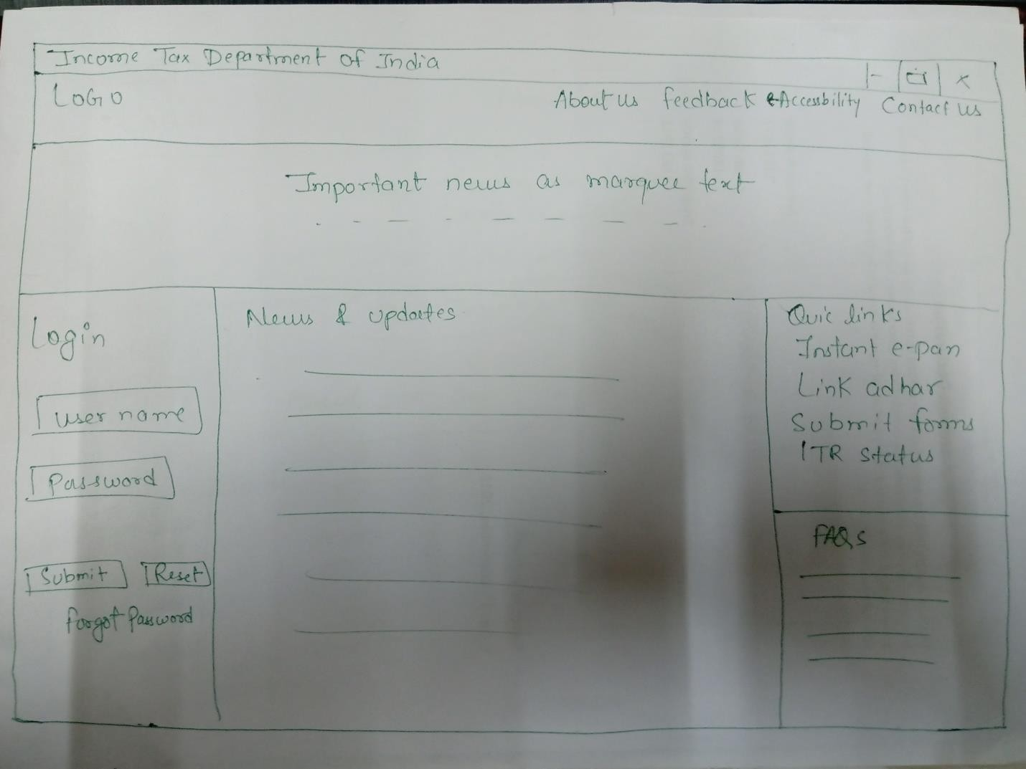

##### Rubrics:

Project 15 **Income tax department of India**

* Pre-submission report - includes module wise description, role and responsibility of each group members and work plan as Gantt chart (5 Marks)
* Final report (5 Marks)
* Viva and Implementation ( 10+10 Marks)

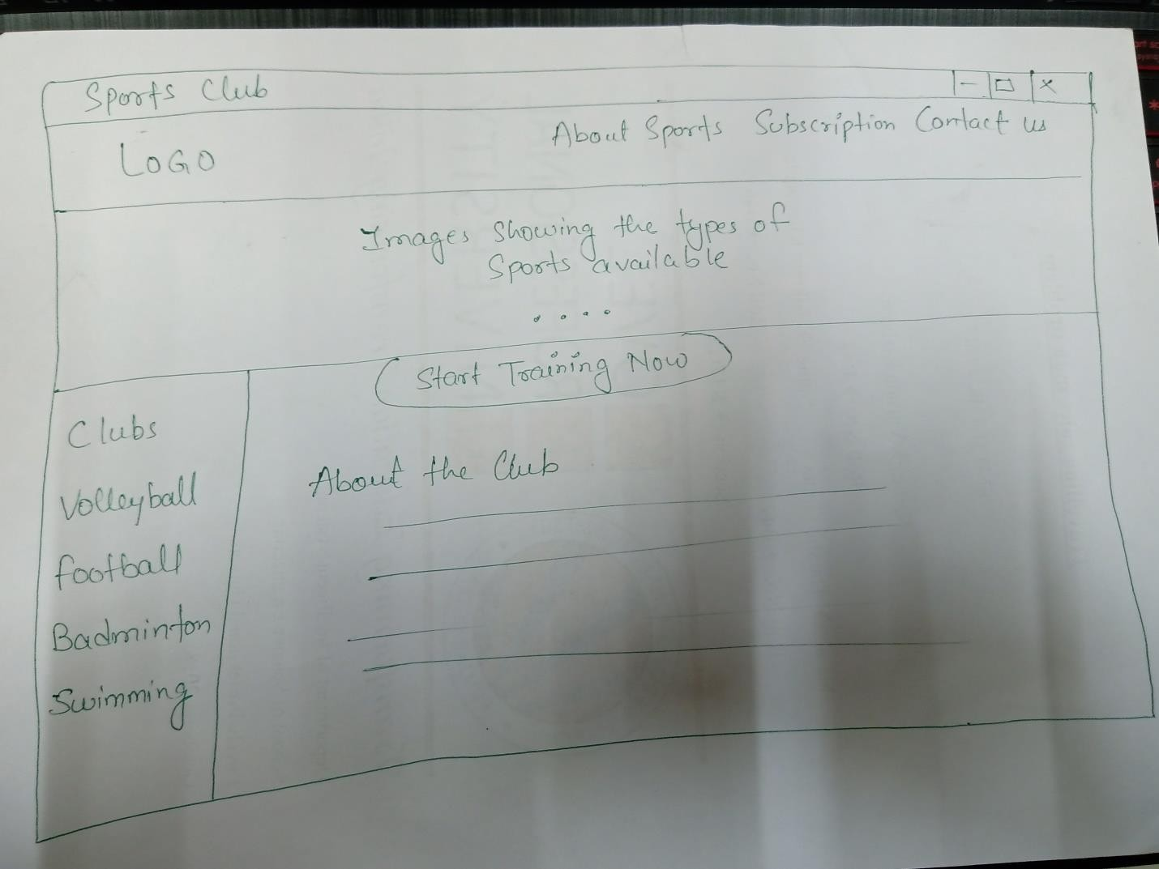

##### Rubrics:

Project 16 **Sport’s Club**

* Pre-submission report - includes module wise description, role and responsibility of each group members and work plan as Gantt chart (5 Marks)
* Final report (5 Marks)
* Viva and Implementation ( 10+10 Marks)

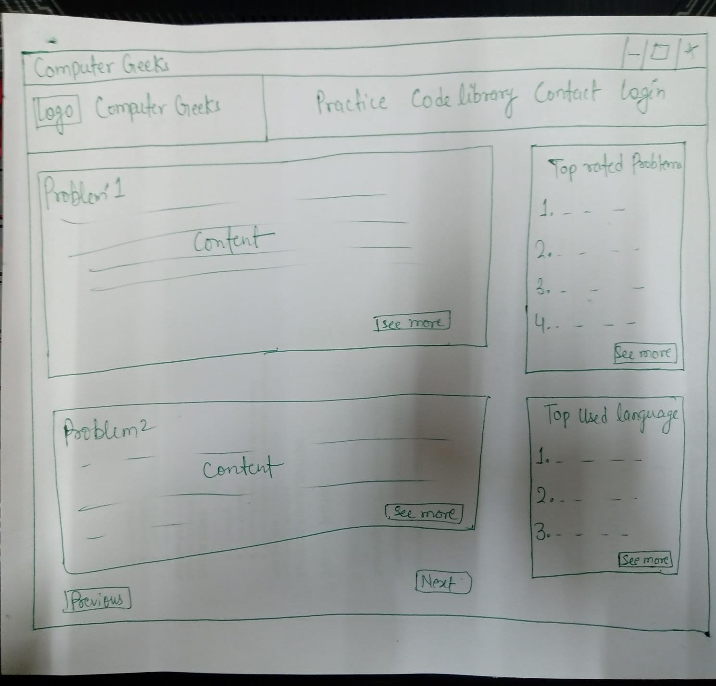

##### Rubrics:

Project 17 **Website for coding practice**

* Pre-submission report - includes module wise description, role and responsibility of each group members and work plan as Gantt chart (5 Marks)
* Final report (5 Marks)
* Viva and Implementation ( 10+10 Marks)

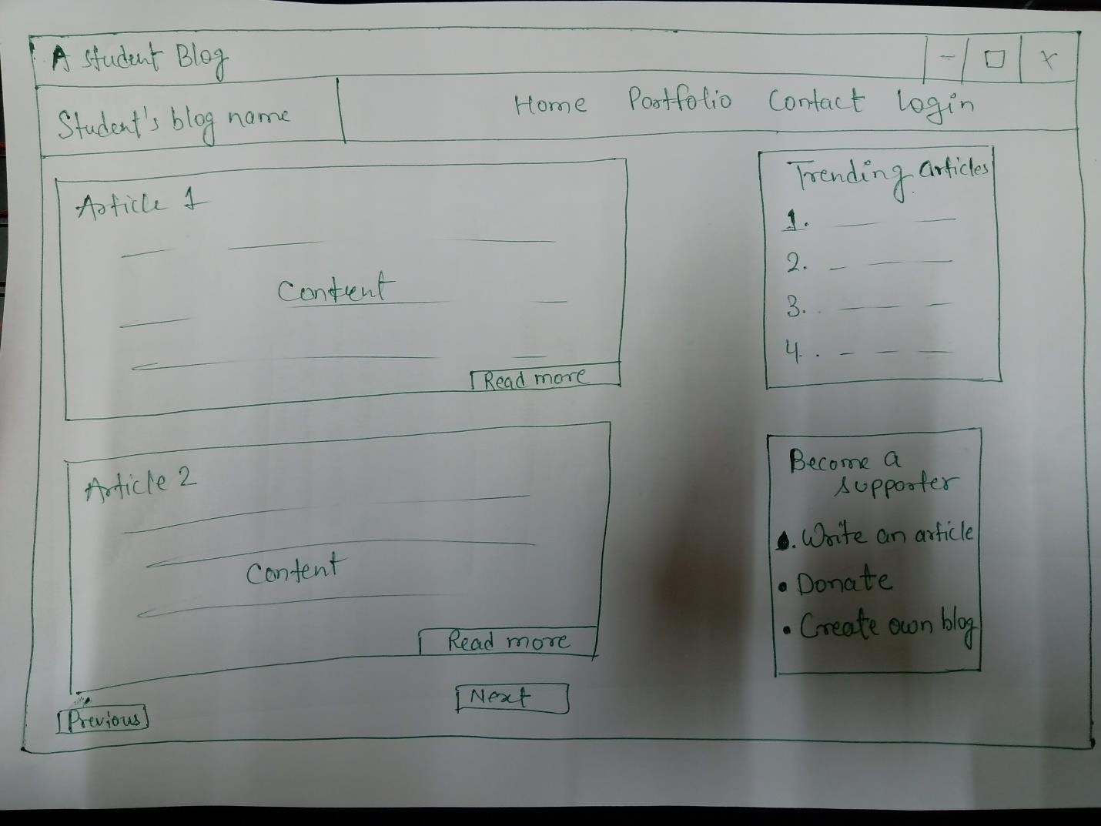

##### Rubrics:

Project 18 **A Blog Website**

* Pre-submission report - includes module wise description, role and responsibility of each group members and work plan as Gantt chart (5 Marks)
* Final report (5 Marks)
* Viva and Implementation ( 10+10 Marks)

# Project 19 Gold’s Gym Website

##### Rubrics:

* Pre-submission report - includes module wise description, role and responsibility of each group members and work plan as Gantt chart (5 Marks)
* Final report (5 Marks)
* Viva and Implementation ( 10+10 Marks)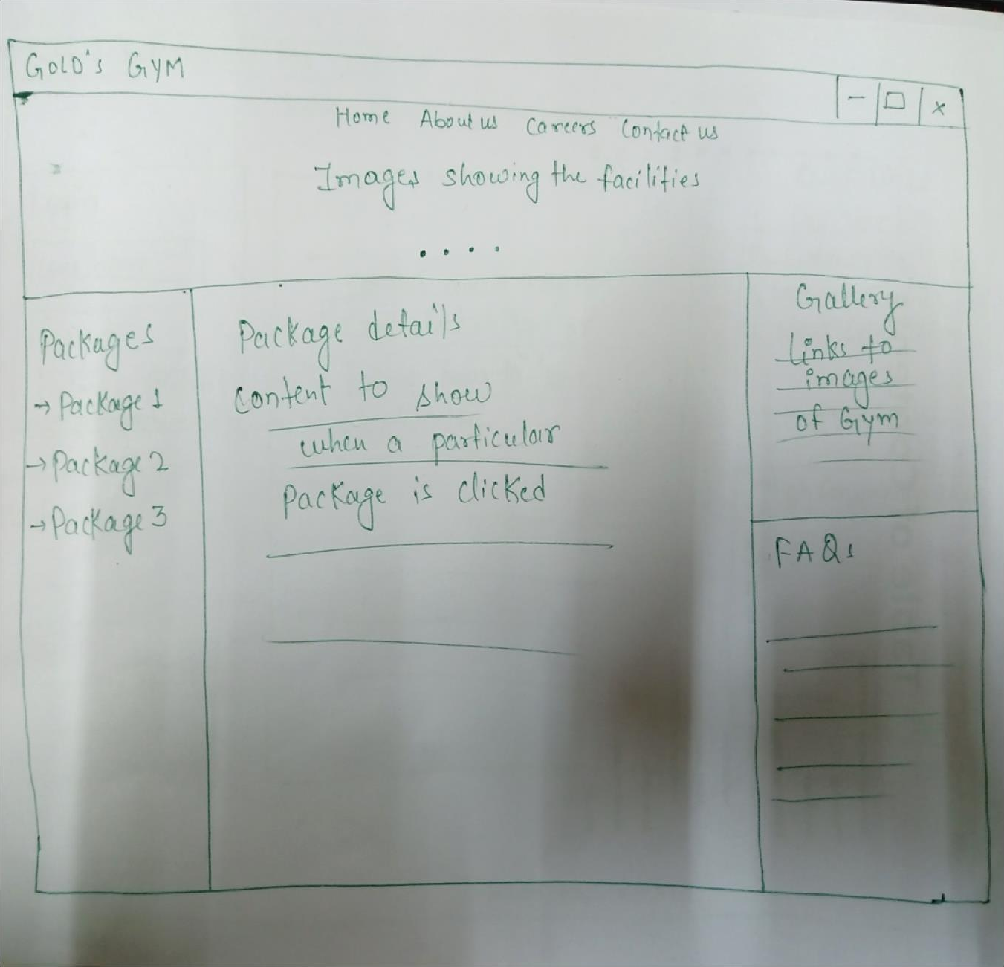

PROJECT 20 : INTERACTIVE CALENDER

Aim : To create a Web-Calendar which helps human being with lot of information on day-to-day life.

##### Rubrics:

* Pre-submission report - includes module wise description, role and responsibility of each group members and work plan as Gantt chart (5 Marks)
* Final report (5 Marks)
* Viva and Implementation ( 10+10 Marks)

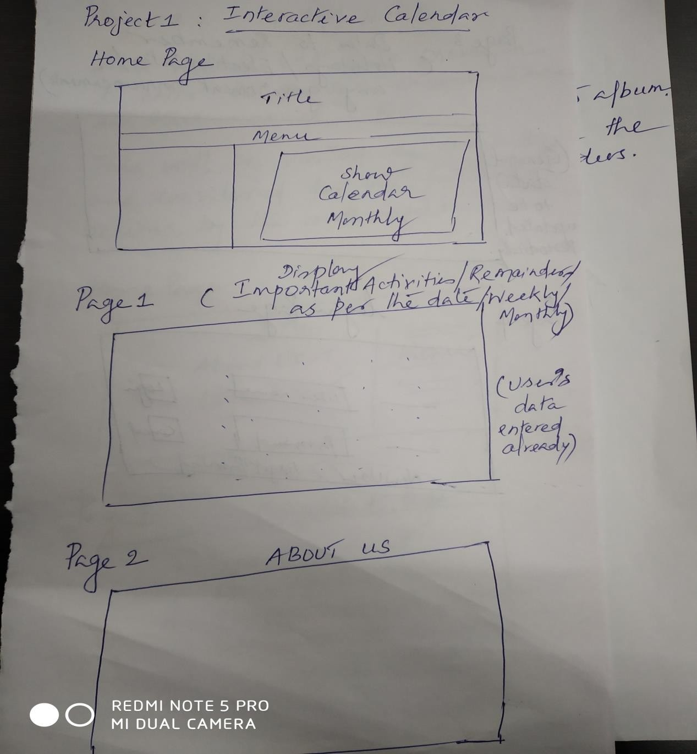

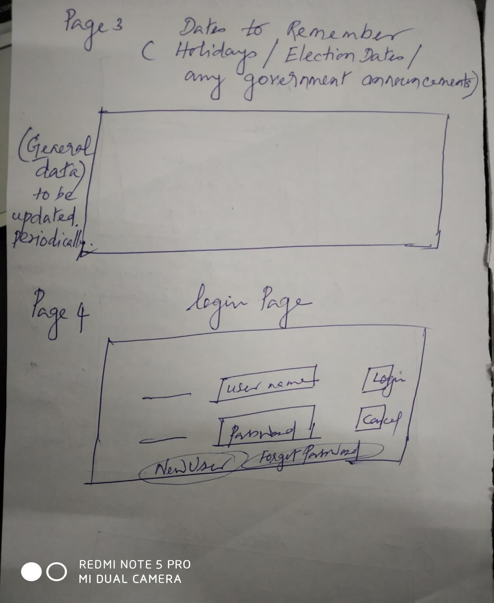

## PROJECT 21 : HELPING HANDS

Aim : To design a website where people can register their complaints about anything from anywhere. It should be specific, so that, the authorities will use the entered information effectively in future.

##### Rubrics:

* Pre-submission report - includes module wise description, role and responsibility of each group members and work plan as Gantt chart (5 Marks)
* Final report (5 Marks)
* Viva and Implementation ( 10+10 Marks)

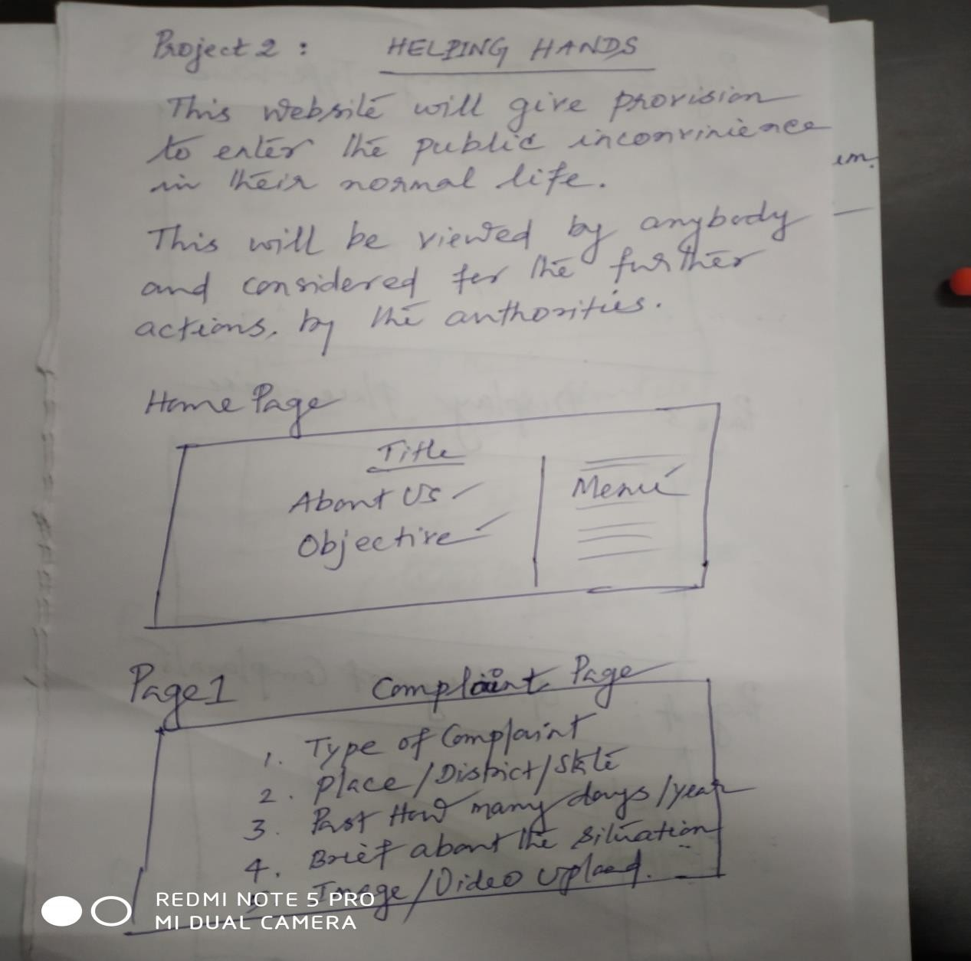

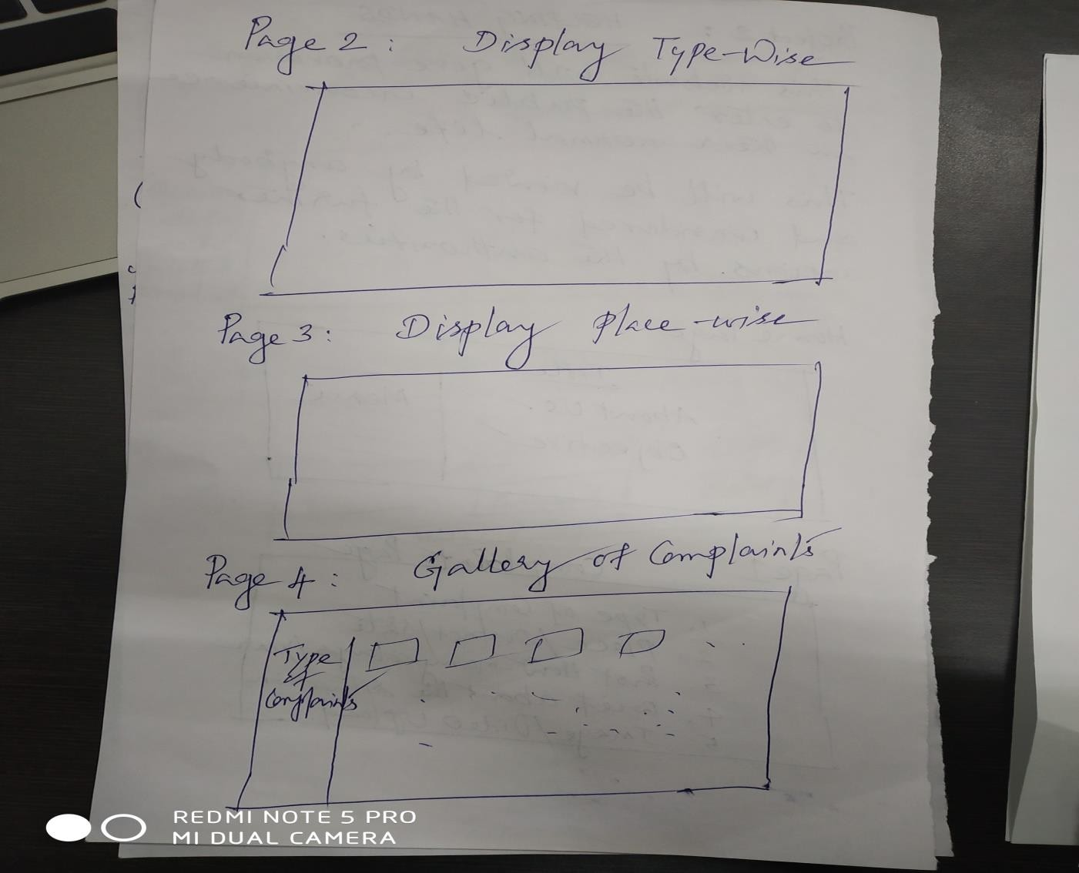

## PROJECT 22 : ONLINE REAL-ESTATE

Aim : To create a website for online real-estate business.

##### Rubrics:

* Pre-submission report - includes module wise description, role and responsibility of each group members and work plan as Gantt chart (5 Marks)
* Final report (5 Marks)
* Viva and Implementation ( 10+10 Marks)

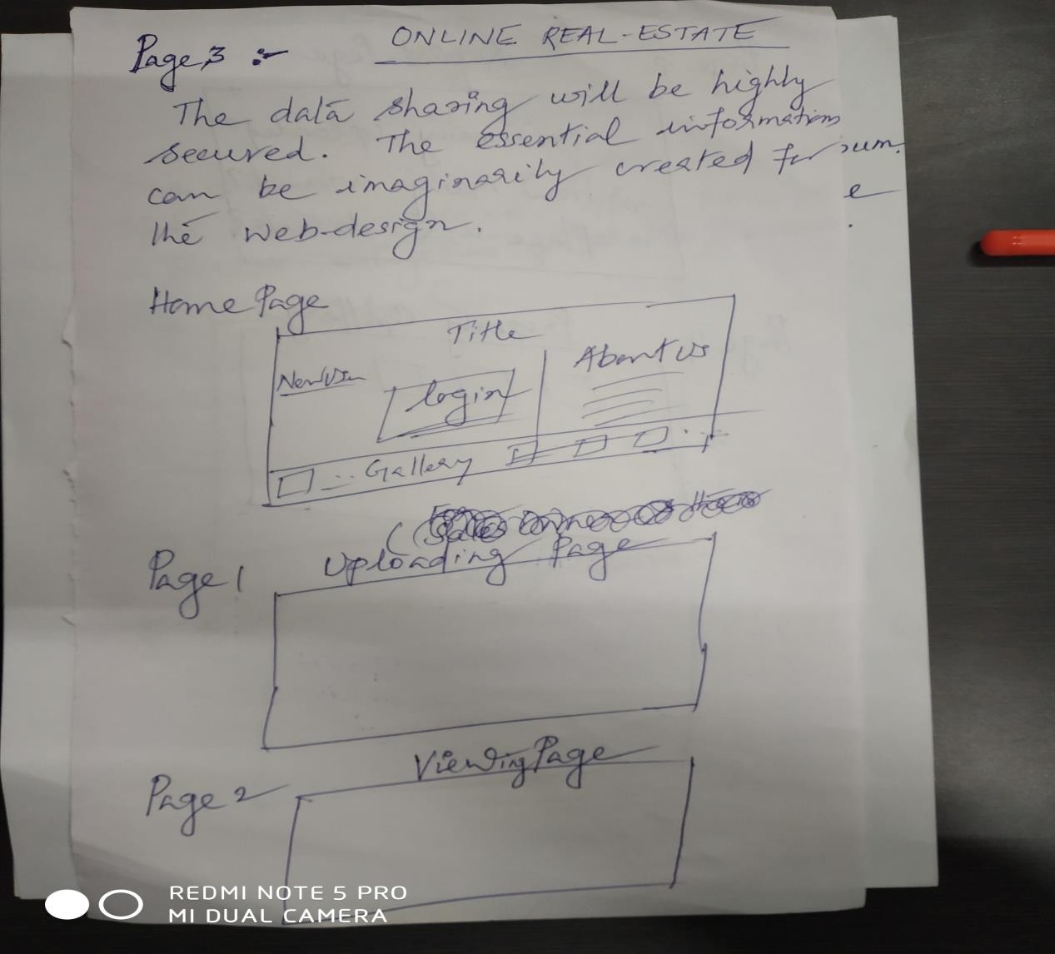

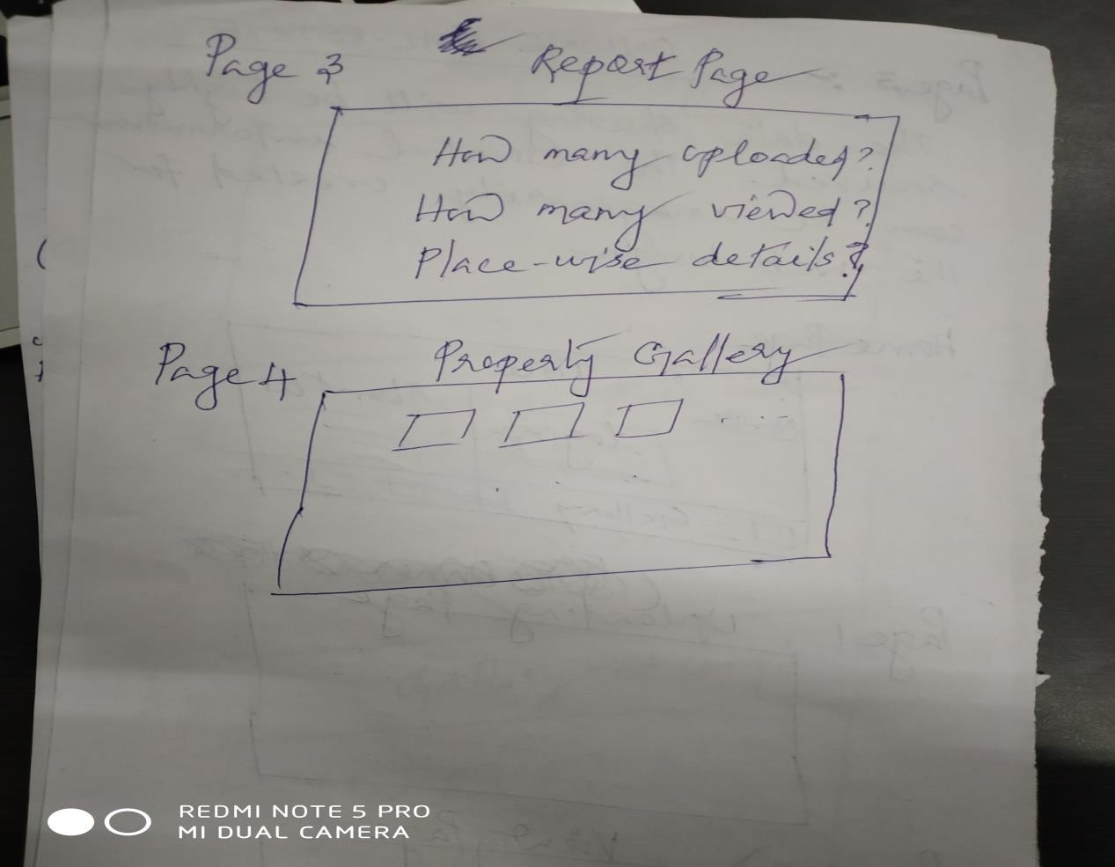

## PROJECT 23 : PERSONAL ALBUM

Aim : To create a website which acts as the personal photo collection and album. The prototype of the album, the categories of photo collection and interactive visuals should be good.

##### Rubrics:

* Pre-submission report - includes module wise description, role and responsibility of each group members and work plan as Gantt chart (5 Marks)
* Final report (5 Marks)
* Viva and Implementation ( 10+10 Marks)

